HW4 Part II: ECR/ECS/Fargate Deployment

Step 1: Load Docker Image & Get ECR URL
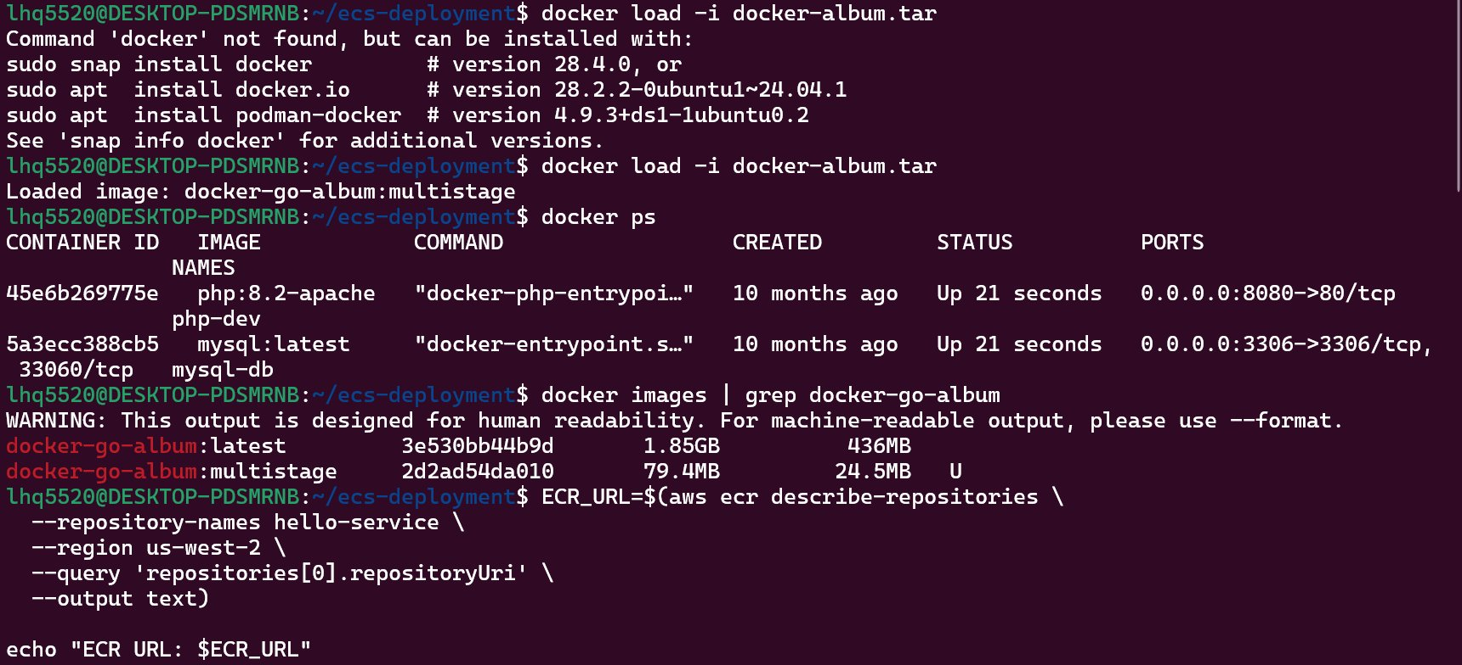
- Loaded pre-built Docker image from docker-album.tar (Go web service)
- Retrieved ECR repository URI using AWS CLI: aws ecr describe-repositories
- ECR URL: 591389222803.dkr.ecr.us-west-2.amazonaws.com/hello-service

Step 2: Authenticate & Push Image to ECR
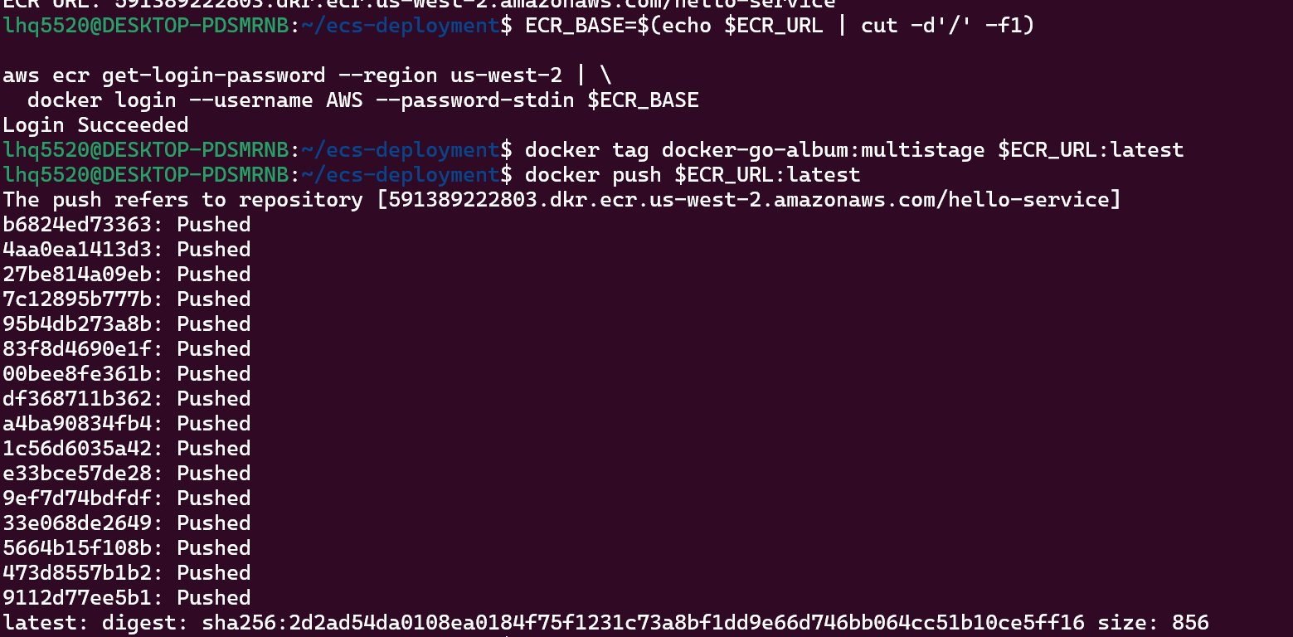
- Extracted ECR base URL and authenticated Docker to ECR using aws ecr get-login-password
- Login Succeeded — Docker is now authorized to push to ECR
- Tagged the multistage image as $ECR_URL:latest
- Pushed image to ECR —
- Image digest: sha256:2d2ad54da0108ea0184f75f1231c73a8bf1dd9e66d746bb064cc51b10ce5ff16

Step 3: Verify Image in ECR
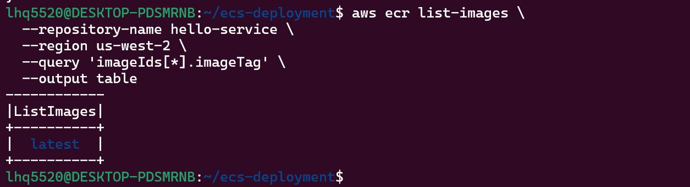
- Ran aws ecr list-images to verify the image was uploaded
- Confirmed: image tagged as "latest" exists in the hello-service repository

Step 4: ECR Console — Repository Overview
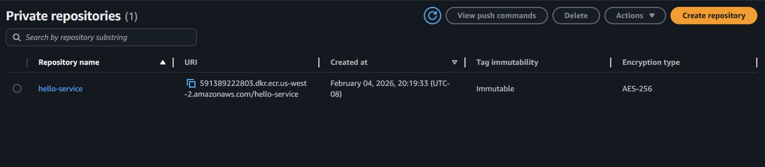
- AWS Console view of ECR showing the hello-service private repository
- Repository URI: 591389222803.dkr.ecr.us-west-2.amazonaws.com/hello-service
- Created: February 04, 2026

Step 5: ECS Cluster — Task Running
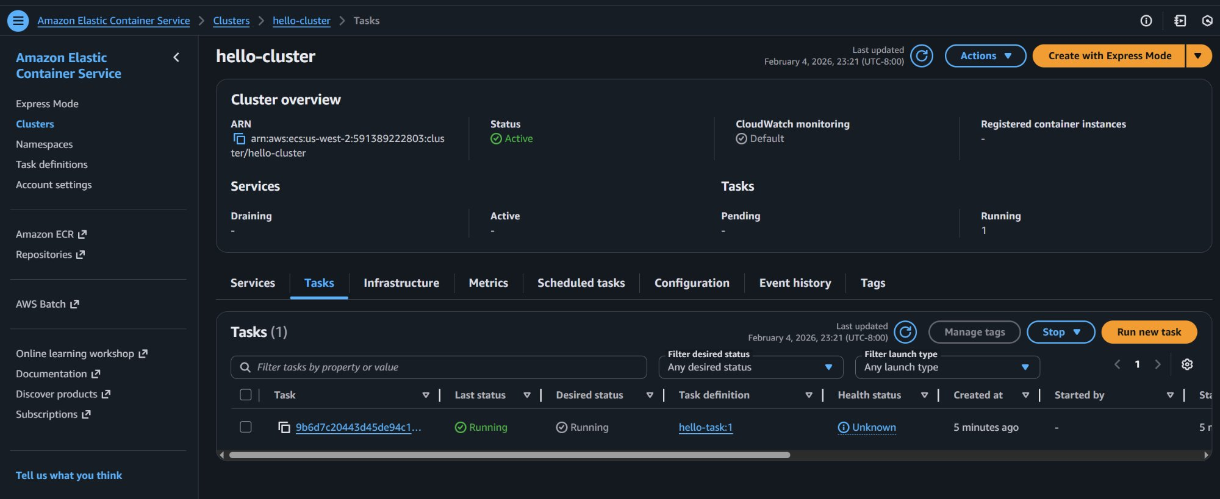
- Created ECS cluster named hello-cluster (Status: Active)
- Using AWS Fargate — serverless, no EC2 instances to manage
- 1 task running with task definition hello-task:1
- Task status: Running (both Last status and Desired status)

Step 6: ECS Task Detail — Container Configuration
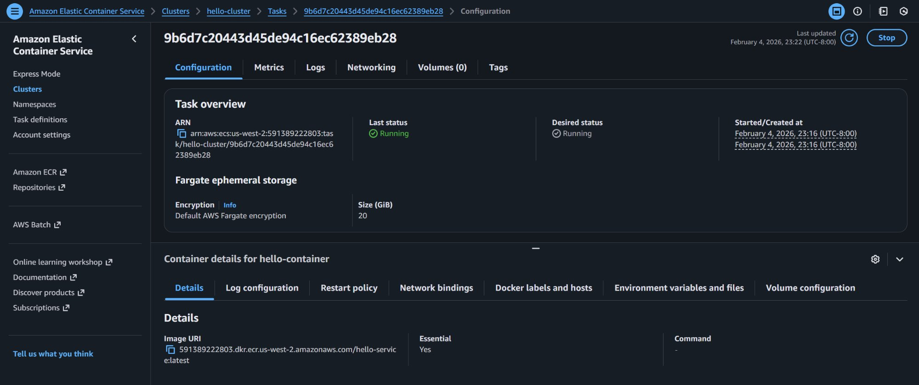
- Task overview: Last status = Running, Desired status = Running
- Started at: February 4, 2026, 23:16 (UTC-8:00)
- Container name: hello-container
- Image URI: 591389222803.dkr.ecr.us-west-2.amazonaws.com/hello-service:latest

Step 7: Network Interface — Finding the Public IP
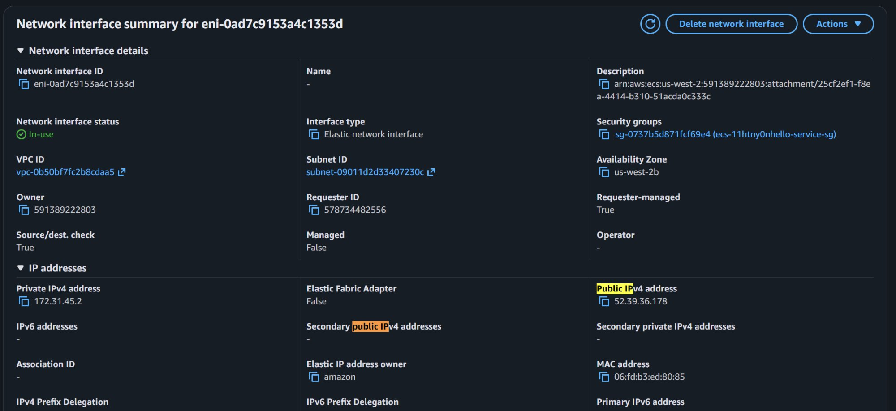
- Navigated from ECS Task → ENI ID → EC2 Network Interface
- VPC ID: vpc-0b50bf7fc2b8cdaa5 (default VPC)
- Subnet: subnet-09011d2d33407230c, Availability Zone: us-west-2b
- Private IPv4: 172.31.45.2
- Public IPv4: 52.39.36.178 — this is the address we use to access the service

Step 8: Testing the Service with curl
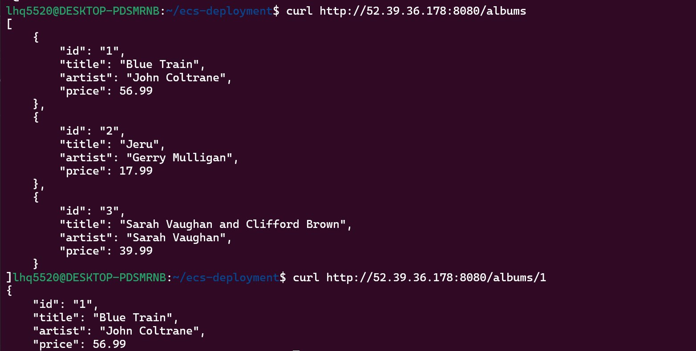
- curl http://52.39.36.178:8080/albums → returned JSON array with 3 albums
- curl http://52.39.36.178:8080/albums/1 → returned single album (Blue Train)
- Service is fully functional and publicly accessible!

